**18.****USING RAPTOR –SWAP TWO NUMBERS**

**Y.NAVEEN KUMAR REDDY**

**192111405**

**FLOWCHART:**

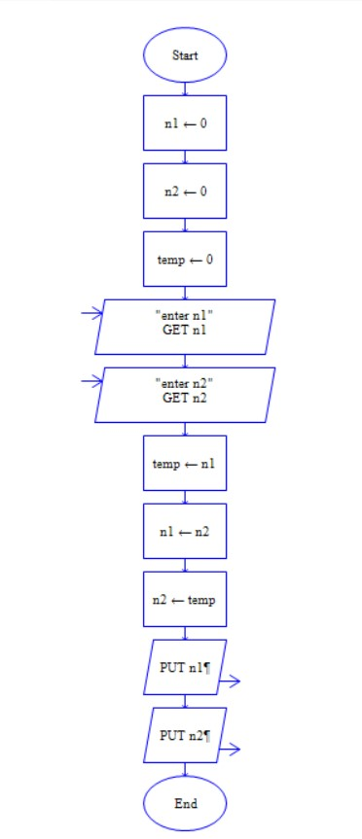

**INPUT:**

FIRST NUMBER: 12 SECOND NUMBER: 56 **OUTPUT:**

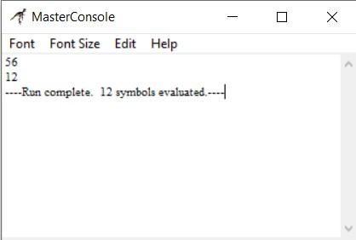

**RESULT:**

The program is executed and verified successfully.